MODULE 3

Module - 3

ADAPTATION OF ANATOMICAL PRINCIPLES FOR BIOENGINEERING DESIGN

Brain as a CPU system. Eye as a Camera system. Heart as a pump system. Lungs as purification system. Kidney as a filtration system.

HUMAN ORGAN SYSTEMS AND BIO DESIGNS:

The human body is a biological machine made of body systems; groups of organs that work together to produce and sustain life. Organ systems are:
Skeletal system, Muscular system, Cardiovascular system, Respiratory system, Nervous system, Digestive system, Urinary system, Endocrine system, Lymphatic system, Reproductive system, Integumentary system.

Biodesign is the use of living organisms in design. Its processes can be used in the creation of fashion, textiles, furniture and architecture. Nonprofits, design companies and universities around the world, including UC Davis, increasingly implement biodesign practices into research and product development.

Bio-design (actual or conceptual) embodies an emerging design movement which incorporates the use of living materials, or ‘moist media,’ such as fungi, algae, yeast, bacteria, and cultured tissue. This can be as part of standard crafting methods or the more complex fields of biomimicry and synthetic biology. The idea is to create a product whose properties are enhanced as a result of the use of these living materials. Some examples are explained below.

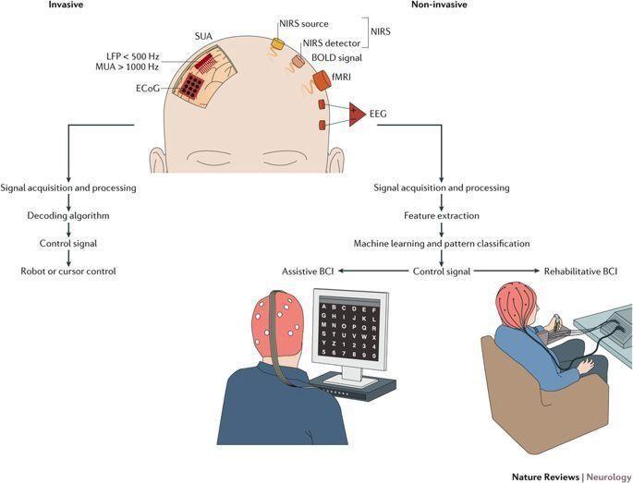

BRAIN AS A CPU SYSTEM:

Both CPU and brain use electrical signals to send messages. The brain uses chemicals to transmit information; the computer uses electricity. Even though electrical signals travel at high speeds in the nervous system, they travel even faster through the wires in a computer. Both transmit information.

A BCI system is a computer-based system that takes brain signals, analyses them and translates them into commands that are relayed to a device to trigger a desired action. A BCI system does not use peripheral nerves and head muscles. The CNS (Central Nervous System), for example, is used to measure signals produced by the central nervous system. Thus, for example, a sensor that is activated by the voice or the movement of a muscle is not a BCI system. Also an EEG is not BCI itself, because it only records brain signals but it does not produce an output that acts on the user's environment. It is also wrong to think that BCI is a mind-reader. They do not export information from unsuspecting users or users unwillingly using the system. They allow users to act in their environment when they want it by reading their brain signals rather than muscles. The user and the BCI work together. The user, after a training session, produces brain signals encoded by the BCI system. The BCI then translates these commands and transmits them into an output device. Brain computer interfaces have contributed to various areas of research. Applications that are about medicine, neuro-technology and smart environment, neuro-marketing and advertising, education and self-regulation, games and entertainment, as well as security and identification.

The nervous system has two main parts: The central nervous system is made up of the brain and spinal cord. The peripheral nervous system is made up of nerves that branch off from the spinal cord and extend to all parts of the body.

- CNS:
CNS includes the brain and spinal cord. The brain is the body’s “control center.” The CNS has various centers located within it that carry out the sensory, motor and integration of data. These centers can be subdivided to Lower Centers (including the spinal cord and brain stem) and higher centers communicating with the brain via effectors.

- PNS:
PNS is a vast network of spinal and cranial nerves that are linked to the brain and the spinal cord. It contains sensory receptors which help in processing changes in the internal and external environment. This information is sent to the CNS via afferent sensory nerves. The PNS is then subdivided into the autonomic nervous system and the somatic nervous system. The autonomic has involuntary control of internal organs, blood vessels, smooth and cardiac muscles. The somatic has voluntary control of skin, bones, joints, and skeletal muscle. The two systems function together, by way of nerves from the PNS entering and becoming part of the CNS, and vice versa.
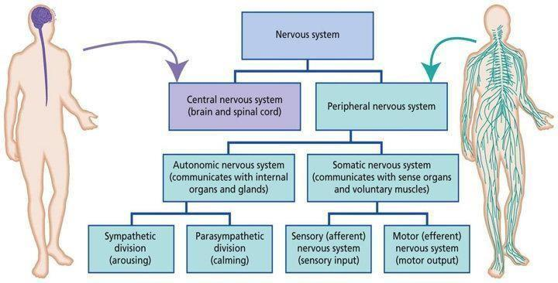
COURTESY: MARC SEYMOUR

SIGNAL TRANSMISSION:

A neuron sending a signal (i.e., a presynaptic neuron) releases a chemical called a neurotransmitter, which binds to a receptor on the surface of the receiving (i.e., postsynaptic) neuron. Neurotransmitters are released from presynaptic terminals, which may branch to communicate with several postsynaptic neurons.
Axon terminals are where neurotransmission begins. Hence, it is at axon terminals where the neuron sends its OUTPUT to other neurons. At electrical synapses, the OUTPUT will be the electrical signal itself. At chemical synapses, the OUTPUT will be neurotransmitter.
The correct outline for the sequence of transmission of an electrical impulse through a neuron is dendrites, cell body, axon, axon terminal.

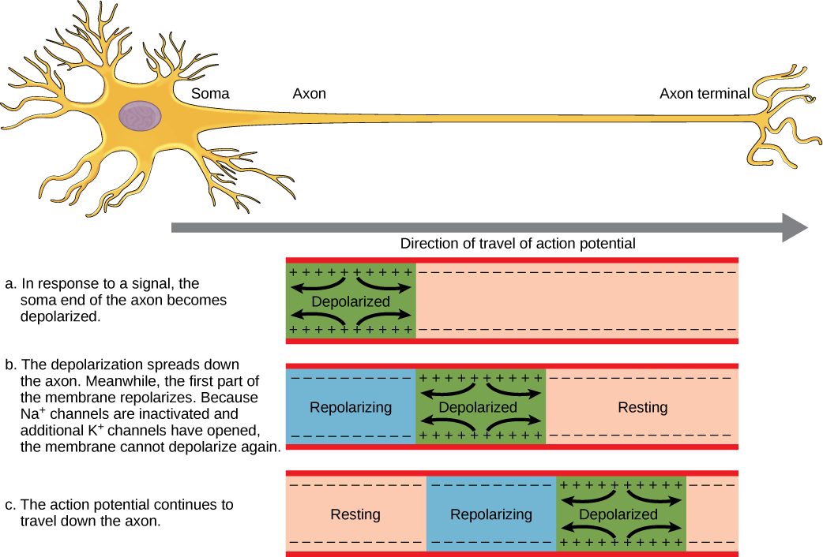
COURTESY: OPENSTAX COLLEGE,BIOLOGY

ELECTRO ENCEPHALO GRAM [EEG]:

An electroencephalogram (EEG) is a test that measures electrical activity in the brain using small, metal discs (electrodes) attached to the scalp. Brain cells communicate via electrical impulses and are active all the time, even during asleep. This activity shows up as wavy lines on an EEG recording.
An EEG is one of the main diagnostic tests for epilepsy. An EEG can also play a role in diagnosing other brain disorders.
An EEG can find changes in brain activity that might be useful in diagnosing brain disorders, especially epilepsy or another seizure disorder. An EEG might also be helpful for diagnosing or treating:

- Brain tumors
- Brain damage from head injury
- Brain dysfunction that can have a variety of causes (encephalopathy)
- Sleep disorders
- Inflammation of the brain (herpes encephalitis)
- Stroke
- Sleep disorders

- Creutzfeldt-Jakob disease
An EEG might also be used to confirm brain death in someone in a persistent coma. A continuous EEG is used to help find the right level of anesthesia for someone in a medically induced coma. Voltage fluctuations measured by the EEG bioamplifier and electrodes allow the evaluation of normal brain activity including the posterior dominant rhythm (PDR), first described by Hans Berger. EEG can detect abnormal electrical discharges such as sharp waves, spikes or spike-and- wave complexes that are seen in people with epilepsy, thus it is often used to inform the medical diagnosis. EEG can detect the onset and spatio-temporal evolution of seizures and the presence of status epilepticus. It is also used to help diagnose sleep disorders, depth of anesthesia, coma, encephalopathies, cerebral hypoxia after cardiac arrest, and brain death. EEG used to be a first- line method of diagnosis for tumors, stroke and other focal brain disorders, but this use has decreased with the advent of high-resolution anatomical imaging techniques such as magnetic resonance imaging (MRI) and computed tomography (CT). Despite limited spatial resolution, EEG continues to be a valuable tool for research and diagnosis. It is one of the few mobile techniques available and offers millisecond-range temporal resolution which is not possible with CT, PET or MRI.

Derivatives of the EEG technique include evoked potentials (EP), which involves averaging the EEG activity time-locked to the presentation of a stimulus of some sort (visual, somatosensory, or auditory). Event-related potentials (ERPs) refer to averaged EEG responses that are time-locked to more complex processing of stimuli; this technique is used in cognitive science, cognitive psychology, and psychophysiological research.
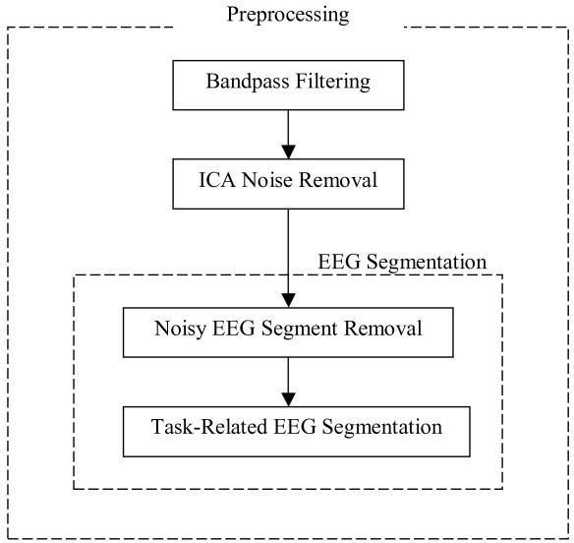

COURTESY: Z. JANE WANG

ROBOTIC ARMS FOR PROSTHETICS:

Robotic prosthetic limb is a well-established research area that integrates advanced mechatronics, intelligent sensing, and control for achieving higher order lost sensorimotor functions while maintaining the physical appearance of amputated limb. Robotic prosthetic limbs are expected to replace the missing limbs of an amputee restoring the lost functions and providing aesthetic appearance. The main aspects are enhanced social interaction, comfortable amputee’s life, and productive amputee to the society. With the advancement of sensor technology, in the last few decades significant contributions have been made in this area.
Most current robotic prostheses work by recording—from the surface of the skin—electrical signals from muscles left intact after an amputation. Some amputees can guide their artificial hand by contracting muscles remaining in the forearm that would have controlled their fingers.
If you are missing an arm or leg, an artificial limb can sometimes replace it. The device, which is called a prosthesis, can help you to perform daily activities such as walking, eating, or dressing. Robotic arms can be used to automate the process of placing goods or products onto pallets. By automating the process, palletizing becomes more accurate, cost-effective, and predictable. The use of robotic arms also frees human workers from performing tasks that present a risk of bodily injury.
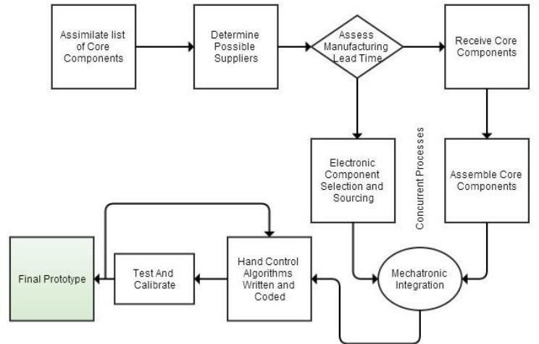
COURTESY: RESEARCH GATE

ENGINEERING SOLUTIONS FOR PARKINSON’S DISEASE:

Parkinson's disease is a progressive disorder that affects the nervous system and the parts of the body controlled by the nerves. Symptoms start slowly. The first symptom may be a barely noticeable tremor in just one hand. Tremors are common, but the disorder may also cause stiffness or slowing of movement.
In Parkinson's disease, certain nerve cells (neurons) in the brain gradually break down or die. Many of the symptoms are due to a loss of neurons that produce a chemical messenger in your brain called dopamine. When dopamine levels decrease, it causes atypical brain activity, leading to impaired movement and other symptoms of Parkinson's disease.
Parkinson's disease can't be cured, but medications can help control the symptoms, often dramatically. In some more advanced cases, surgery may be advised. Your health care provider may also recommend lifestyle changes, especially ongoing aerobic exercise.

ENGINEERING SOLUTIONS TO THIS DISEASE ARE:

Deep Brain Stimulation – Deep Brain Stimulation (DBS) involves surgically implanting a neurotransmitter that sends electrical impulses to specific areas of your brain. This procedure has helped many people with Parkinson's reduce symptoms such as tremor, rigidity, and bradykinesia. There are six main types of medications available to treat symptoms of Parkinson disease: levodopa, dopamine agonists, and inhibitors of enzymes that inactivate dopamine (monoamine oxidase type B [MAO B] inhibitors and catechol-O-methyl transferase [COMT] inhibitors, anticholinergic drugs, and amantadine.

ENGINEERING NEURONS are another treatment method for this.
Transplantation of embryonic neurons can restore functional dopaminergic neurons in the brains of patients with Parkinson's disease. But while promising, cell transplantation therapy is still out of reach to most patients, in part because of the inaccessibility of human embryonic tissue.

First obtained neuronal stem cells from mouse cells transfected with a transcription factor that encourages cells to adopt a neuronal fate. They then co-cultured the cells with astrocytes, which release a factor that induces development into dopaminergic neurons. The engineered cells released dopamine, and some maintained the characteristics of dopaminergic neurons for up to two weeks after implantation into mouse brains.

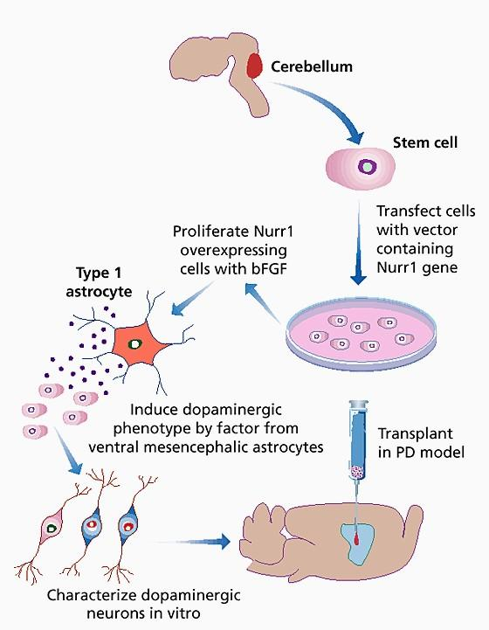

EYE AS A CAMERA SYSTEM:

The human eye is a wonderful instrument, relying on refraction and lenses to form images. There are many similarities between the human eye and a camera, including:
A diaphragm to control the amount of light that gets through to the lens. This is the shutter in a camera, and the pupil, at the center of the iris, in the human eye. A lens to focus the light and create an image. The image is real and inverted. A method of sensing the image. In a camera, film is used to record the image; in the eye, the image is focused on the retina, and a system of rods and cones is the front end of an image-processing system that converts the image to electrical impulses and sends the information along the optic nerve to the brain.
There are two photoreceptors: RODS AND CONES

These photoreceptors are localized around an area near the centre of the retina called the macula, which is the functional center of the retina. The fovea is located in the centre of the macula. The macula is responsible for high-resolution, color vision, provided by different types of photoreceptors.

Photoreceptors in the retina are classified into two groups, named after their physical morphologies. Rod cells are highly sensitive to light and function in night vision, whereas cone cells are capable of detecting a wide spectrum of light photons and are responsible for colour vision. Rods and cones are structurally compartmentalized. They consist of five principal regions: Outer segment, connecting cilium, Inner segment, nuclear region, Synaptic region, Rods are responsible for vision at low light levels (scotopic vision). They do not mediate color vision and have a low spatial acuity.
Cones are active at higher light levels (photopic vision), are capable of color vision and are responsible for high spatial acuity. The central fovea is populated exclusively by cones. There are 3 types of cones which we will refer to as the short-wavelength sensitive cones, the middle- wavelength sensitive cones and the long-wavelength sensitive cones or S-cone, M-cones, and L- cones for short.

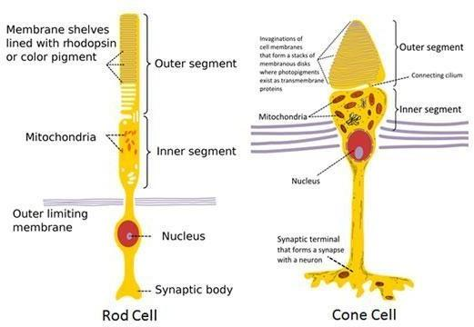
COURTESY: EASY BIOLOGY CLASS

OPTICAL CORRECTIONS:

A slight modification of geometrically correct lines (as of a building) for the purpose of making them appear correct to the eye.
The ability to see images or objects with clear, sharp vision results from light entering the eye. Light rays bend or refract when they hit the retina, sending nerve signals to the optic nerve, which then sends these signals to the brain. The brain processes them into images, allowing you to understand what you see. When these light rays bend incorrectly, it results in a refractive error and typically causes blurry or cloudy vision.
Since the primary cause of vision problems is caused by light bending incorrectly as it enters the eye, virtually any method of treatment that changes this can be categorized as a form of vision correction.
Eyeglasses and contact lenses – the most common types of corrective measures – are almost always recommended as the first course of treatment for vision problems. While they are considered a very basic method of vision correction, they are unable to control the refractive error from progressing. Patients whose vision worsens over time need new glasses or contacts. In these cases, longer-term solutions are needed.

CATARACT:

A cataract is a clouding of the normally clear lens of the eye. At first, the cloudiness in your vision caused by a cataract may affect only a small part of the eye's lens and you may be unaware of any vision loss. As the cataract grows larger, it clouds more of your lens and distorts the light passing through the lens. This may lead to more-noticeable symptoms. A cataract is a cloudy lens. The lens is positioned behind the colored part of your eye (iris). The lens focuses light that passes into your eye, producing clear, sharp images on the retina — the light-sensitive membrane in the eye that functions like the film in a camera.
As you age, the lenses in your eyes become less flexible, less transparent and thicker. Age-related and other medical conditions cause proteins and fibers within the lenses to break down and clump together, clouding the lenses.

As the cataract continues to develop, the clouding becomes denser. A cataract scatters and blocks the light as it passes through the lens, preventing a sharply defined image from reaching your retina. As a result, your vision becomes blurred. Cataracts generally develop in both eyes, but not always at the same rate. The cataract in one eye may be more advanced than the other, causing a difference in vision between eyes. Cataracts may be partial or complete, stationary or progressive, hard or soft. Histologically, the main types of age-related cataracts are nuclear sclerosis, cortical, and posterior subcapsular.

Nuclear sclerosis is the most common type of cataract, and involves the central or 'nuclear' part of the lens. This eventually becomes hard, or 'sclerotic', due to condensation on the lens nucleus and the deposition of brown pigment within the lens. In its advanced stages, it is called a brunescent cataract. In early stages, an increase in sclerosis may cause an increase in refractive index of the lens. This causes a myopic shift (lenticular shift) that decreases hyperopia and enables presbyopic patients to see at near without reading glasses. This is only temporary and is called second sight. Cortical cataracts are due to the lens cortex (outer layer) becoming opaque. They occur when changes in the fluid contained in the periphery of the lens causes fissuring. When these cataracts are viewed through an ophthalmoscope, or other magnification system, the appearance is similar to white spokes of a wheel. Symptoms often include problems with glare and light scatter at night. Posterior subcapsular cataracts are cloudy at the back of the lens adjacent to the capsule (or bag) in which the lens sits. Because light becomes more focused toward the back of the lens, they can cause disproportionate symptoms for their size.

An immature cataract has some transparent protein, but with a mature cataract, all the lens protein is opaque. In a hypermature or Morgagnian cataract, the lens proteins have become liquid. Congenital cataract, which may be detected in adulthood, has a different classification and includes lamellar, polar, and sutural cataracts.

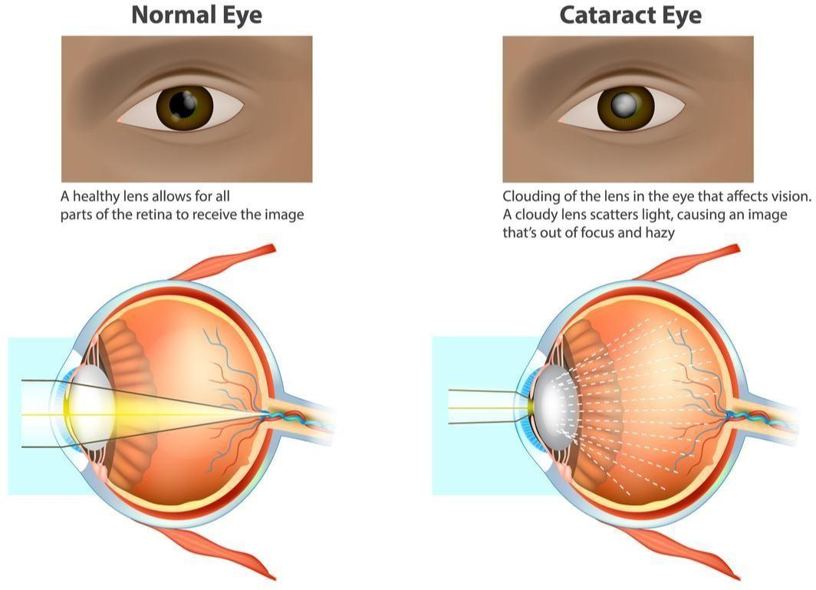
COURTESY: THE EYE HEALTH CENTRE

LENS MATERIALS:

Corrective spherocylindrical lenses are commonly used to treat refractive errors such as myopia, hyperopia, presbyopia, and astigmatism. Both lenses and prisms are also frequently used to improve eye alignment and treat diplopia in strabismus. Eyeglasses also serve an important role in protecting the eyes from physical trauma and harmful radiation. Lenses can be produced using a variety of materials and designed with several optical profiles to optimize use in specific applications. Critical lens properties include refractive index, Abbe number (chromatic dispersion), specific gravity, and ultraviolet absorption.
The most common lens material is, of course, optical glass, but crystals and plastics are frequently used, while mirrors can be made of essentially anything that is capable of being polished.
There are 5 main types of lens materials for eyeglasses and sunglasses. Each type of lens material can help correct refractive errors such as nearsightedness, farsightedness, astigmatism, or presbyopia.
Types of lens materials:

- CR-39: The most used plastic lens material for years was CR-39. It was first developed as a replacement for glass lenses during World War II. It still has 55% of world market at age 60. The patent was awarded to Muskat and Strain of Pittsburgh Plate Glass Company (now named PPG)

in 1946. CR-39 is available in all lens styles and from multiple manufacturers. The basic monomer comes from PPG, and then each company adds their own materials to create their
lenses. Advantages include light weight, good optical properties, and tinting well. Disadvantages of CR-39 are that it is the thickest material and scratches easily.

- Crown Glass is the most commonly used clear glass for ophthalmic lenses. In general, glass is the most durable material used for lenses. Crown glass is used mainly for single vision lenses and the distance carrier for most glass bifocals and trifocals. It has an index of refraction of 1.523, and an Abbe value of 59. It is approximately 4% thinner than CR-39 resin lenses and is 40% heavier than polycarbonate lenses and is slightly lighter than high index glass. It blocks out about 10% of UV light.

- Flint Glass uses lead oxides in its chemical make up to increase its index of refraction to approximately 1.58 to 1.69. Its Abbe value ranges from 30 to 40. This material is relatively soft, displays a brilliant luster and has chromatic aberration. Although it was used in the past as a single vision alternative for higher Rx lenses, its use today is often limited to segments for some fused bifocals.
The advantages of glass lenses include optical clarity, resistance to scratches, and it is the least susceptible to chemicals. The disadvantages include that it is the heaviest material and it is less impact resistant than other materials.

- Polycarbonate Lenses: Polycarbonate lenses were first developed by a company named Gentex. Polycarbonate is a thermoplastic which means it is moldable under sufficient heat. In the 1950's it was marketed under the name Lexan and due to its extraordinary resistance to impact was originally manufactured for safety devices.

BIONIC EYES:

bionic eye, electrical prosthesis surgically implanted into a human eye in order to allow for the transduction of light (the change of light from the environment into impulses the brain can process) in people who have sustained severe damage to the retina.
The bionic eye comprises an external camera and transmitter and an internal microchip. The camera is mounted on a pair of eyeglasses, where it serves to organize the visual stimuli of the environment before emitting high-frequency radio waves. The stimulator microchip consists of an electrode array that is surgically implanted into the retina. That functions as an electrical relay in place of degenerated retinal cells. The radio waves that are emitted by the external camera and transmitter are received by the stimulator, which then fires electrical impulses. The impulses are relayed by the few remaining retinal cells and are transduced as normal to the optic nerve pathway, resulting in vision.

The bionic vision system consists of a camera, attached to a pair of glasses, which transmits high- frequency radio signals to a microchip implanted in the retina. Electrodes on the implanted chip convert these signals into electrical impulses to stimulate cells in the retina that connect to the optic nerve.

It is an expensive treatment and not everyone can afford it. b. Since research is still going on results are yet not 100% successful.

It’s an artificial eye which provide visual sensations to the brain. It consist of electronic systems having image sensors, microprocessors, receivers, radio transmitters and retinal chips. Technology provided by this help the blind people to get vision again.
It consist of a computer chip which is kept in the back of effected person eye and linked with a mini video camera built into glasses that they wear. Then an image captured by the camera are focused to the chip which converts it into electronic signal that brain can interpret. The images produced by Bionic eye were not be too much perfect but they could be clear enough to recognize. The implant bypasses the diseased cells in the retina and go through the remaining possible cells.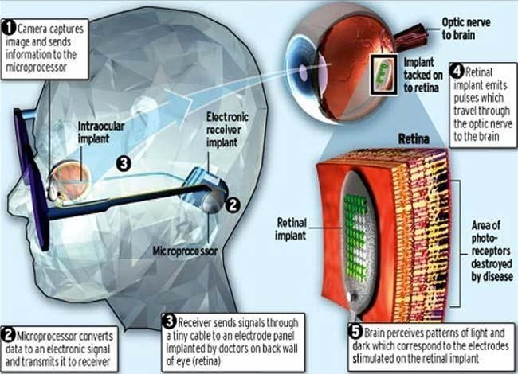

COURTESY: CIRCUITDIGEST

The device consists of 3,500 micro photodiodes which are set at the back part of the retina. The electrical signal which is sent to brain is obtained from these miniature solar cells array as they convert the normal light to electrical signal.

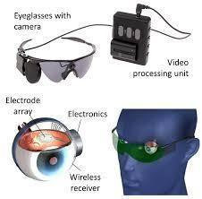

HEART AS A PUMP SYSTEM:

Heart is sort of like a pump, or two pumps in one. The right side of your heart receives blood from the body and pumps it to the lungs. The left side of the heart does the exact opposite: It receives blood from the lungs and pumps it out to the body. While an LVAD consists of thick tubes and a pump connected externally to the heart muscle and aorta, percutaneous heart pumps place a much smaller tube inside the heart's chambers. These tiny heart pumps are placed in the heart via a thin tube called a catheter that is threaded through a puncture site in the skin. The human heart is very strong and is capable of pumping blood up to 30 feet distance. An average heart beats maximum of 70-80 beats per minute and is considered healthy. The efficiency of the heart can be maintained and improved by performing physical activity. The heart is called a double pump because each side pumps blood to a different circulation. Deoxygenated blood from the body drains to the right side of the heart. This is the first pump that sends blood to the lungs, called the pulmonary circulation, where it becomes oxygenated and releases carbon dioxide.

Here is what happens as blood flows through the heart and lungs:
The blood first enters the right atrium. The blood then flows through the tricuspid valve into the right ventricle. When the heart beats, the ventricle pushes blood through the pulmonic valve into the pulmonary artery. The pulmonary artery carries blood to the lungs where it “picks up” oxygen. It then leaves the lungs to return to the heart through the pulmonary vein. The blood enters the left atrium. It drops through the mitral valve into the left ventricle. The left ventricle then pumps blood through the aortic valve and into the aorta. The aorta is the artery that feeds the rest of the body through a system of blood vessels. Blood returns to the heart from the body via two large blood vessels called the superior vena cava and the inferior vena cava. This blood carries little oxygen, as it is returning from the body where oxygen was used. The vena cava pump blood into the right atrium and the cycle begins all over again.

COURTESY: SEER TRAINING MODULES

The human heart is a four-chambered muscular organ, shaped and sized roughly like a man's closed fist with two-thirds of the mass to the left of midline. The heart is enclosed in a pericardial sac that is lined with the parietal layers of a serous membrane. The visceral layer of the serous membrane forms the epicardium.
The myocardium of the heart wall is a working muscle that needs a continuous supply of oxygen and nutrients to function efficiently. For this reason, cardiac muscle has an extensive network of blood vessels to bring oxygen to the contracting cells and to remove waste products.

ELECTRICAL SIGNALING:

The sinus node generates an electrical stimulus regularly, 60 to 100 times per minute under normal conditions. The atria are then activated. The electrical stimulus travels down through the conduction pathways and causes the heart's ventricles to contract and pump out blood.

ECG MONITORING:

ECG monitoring systems have been developed and widely used in the healthcare sector for the past few decades and have significantly evolved over time due to the emergence of smart enabling technologies.
Nowadays, ECG monitoring systems are used in hospitals, homes, outpatient ambulatory settings, and in remote contexts. They also employ a wide range of technologies such as IoT, edge computing, and mobile computing. In addition, they implement various computational settings in terms of processing frequencies, as well as monitoring schemes. They have also evolved to serve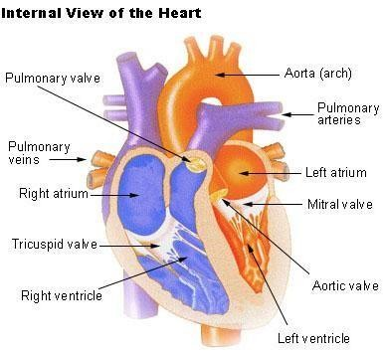

purposes and targets other than disease diagnosis and control, including daily activities, sports, and even mode-related purposes.

This massive diversity in ECG monitoring systems’ contexts, technologies, computational schemes, and purposes makes it hard for researchers and professionals to design, classify, and analyze ECG monitoring systems. Some efforts attempted to provide a common understanding of ECG monitoring systems’ processes, guiding the design of efficient monitoring systems. However, these studies lack comprehensiveness and completeness.
They work for specific contexts, serve specific targets, or are suitable for specific technologies. This makes the available ECG monitoring system processes and architectures hard to generalize and reuse. On the other hand, some studies attempted to analyze ECG monitoring systems’ attributes and provide classification taxonomies, supporting better analysis and understanding of the ECG systems reported in the literature. However, exiting reviews related to ECG monitoring in the literature can be intuitive and incomprehensive.

They do not consider the latest technological trends, and they target very narrow research niches, such as wearable sensors, mobile sensors, disease diagnosis, heartbeat detection, emotion recognition, or ECG compression methods. Hence, there is a need to provide a comprehensive, expert-verified taxonomy of ECG monitoring systems, a common architecture, and a complete set of processes to guide the classification, analysis, and design of these systems.

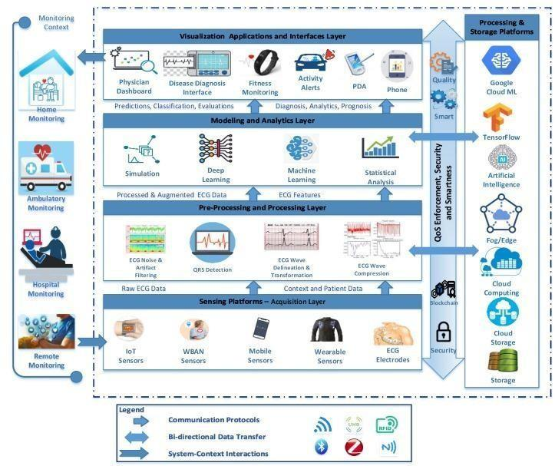
COURTESY: MDPI

The existing ECG classification algorithms usually include signal preprocessing, such as wavelet transform and manual feature extraction, but the amount of computation will increase the delay of the real-time classification system. In recent years, deep learning algorithm with their advantages of automatic learning features is increasingly used in the field of health care, such as medical image recognition and segmentation, time series data monitoring, and analysis. At present, the outstanding algorithm can establish an end-to-end DNN network to learn the characteristics of ECG records by using the extensive digital characteristics of ECG data, which saves a lot of signal preprocessing steps. Because the performance of DNN increases with the amount of training data, this method can make good use of the extensive digitization of ECG data.
Arrhythmias are any abnormal activation sequence of the myoscardium. Some of these include myocardial infarction, which is caused by the sudden loss of blood supply to the heart. One of the most difficult and essential health problems in the real world is the prediction of heart disease. This condition affects the function of blood vessels and can weaken the body of the patient. According to the WHO, around 18 million people die yearly due to heart disease globally.
Due to the increasing prevalence of cardiac diseases, people are prone to prevent devastating event from happening. They are used to diagnose a patient's cardiac condition.

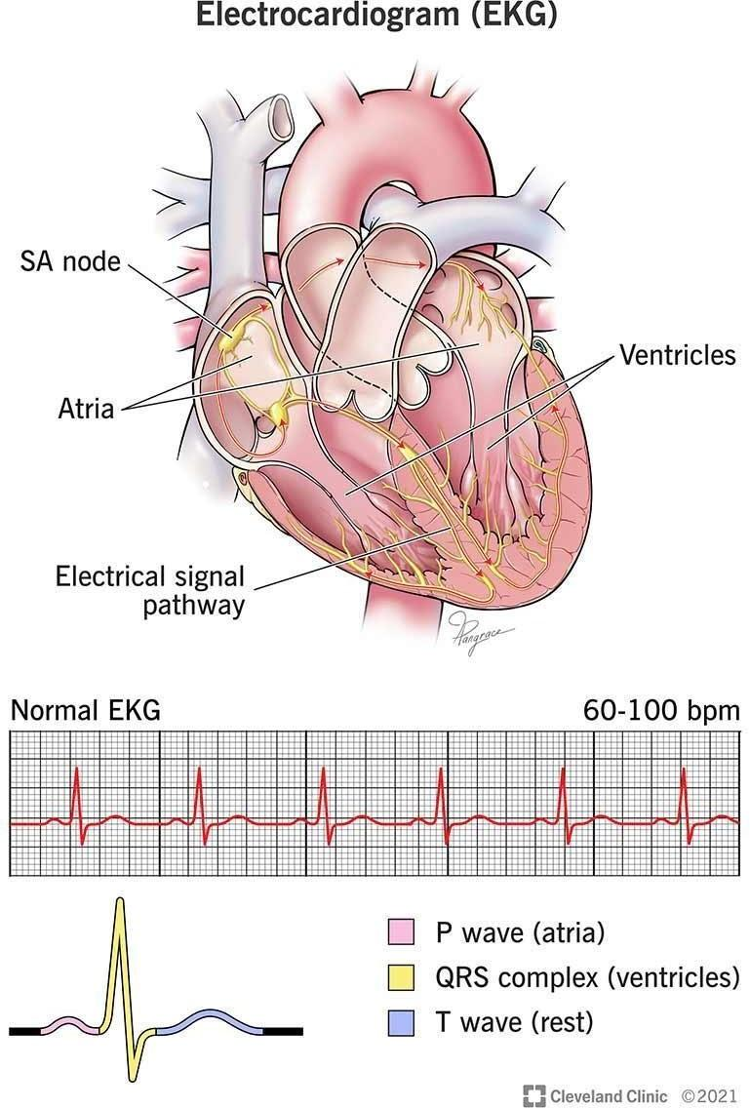

Electrocardiography (ECG) is a quick and easily accessible method for diagnosis and screening of cardiovascular diseases including heart failure (HF). Artificial intelligence (AI) can be used for semi-automated ECG analysis. The aim of this evaluation was to provide an overview of AI use in HF detection from ECG signals and to perform a meta-analysis of available studies.

Evaluation of symptoms suggestive of HF currently demands physicians to valuate various parameters including imaging and laboratory data and the electrocardiogram (ECG). Besides a standard examination that includes an ECG, imaging information, such as echocardiography or magnetic resonance imaging, is seen as gold standard in diagnosis of HF. Nevertheless, an adequate use of such imaging data is associated with relevant technical infrastructure and medical expertise. The ECG is a well-established, quick, and easily accessible method for diagnosis and screening of various cardiovascular diseases. It provides specific features that indicate presence of HF or prognosis in HF patients especially to rule out HF in case of a normal ECG. However, use of an ECG as primary diagnostic instrument often only yields insufficient diagnostic specificity. Further, general practitioner–based ECG reporting has varying results, introducing further diagnostic uncertainty.

Devices providing medically relevant information generated directly by individuals outside the healthcare system such as smartphones with health applications or wearables including smartwatches are an emerging trend. This development promises that a growing number of, e.g., ECG data generated at home will be available for a diagnostic screening. Such data have already shown potential in computer-aided decision support systems to warn patients of rhythmic abnormalities. Management of this quantity of data, however, might be a challenge for the individual healthcare professional, as well as for the healthcare system itself. The potentially beneficial use of artificial intelligence (AI) in cardiology in general has been discussed already, e.g., as a tool for clinicians that could facilitate precision in daily practice and even might improve patient outcomes. AI might also be able to help in interpretation of ECG signals and could therefore be used to analyze ECG data in specific cases and on a large scale for early identification of cardiovascular diseases such as HF.

REASONS FOR BLOCKAGES OF BLOOD VESSELS:

Coronary artery disease is a common heart condition. The major blood vessels that supply the heart (coronary arteries) struggle to send enough blood, oxygen and nutrients to the heart muscle. Cholesterol deposits (plaques) in the heart arteries and inflammation are usually the cause of coronary artery disease.

Signs and symptoms of coronary artery disease occur when the heart doesn't get enough oxygen- rich blood. If you have coronary artery disease, reduced blood flow to the heart can cause chest pain (angina) and shortness of breath. A complete blockage of blood flow can cause a heart attack. Coronary artery disease starts when fats, cholesterols and other substances collect on the inner walls of the heart arteries. This condition is called atherosclerosis. The buildup is called plaque. Plaque can cause the arteries to narrow, blocking blood flow. The plaque can also burst, leading to a blood clot.

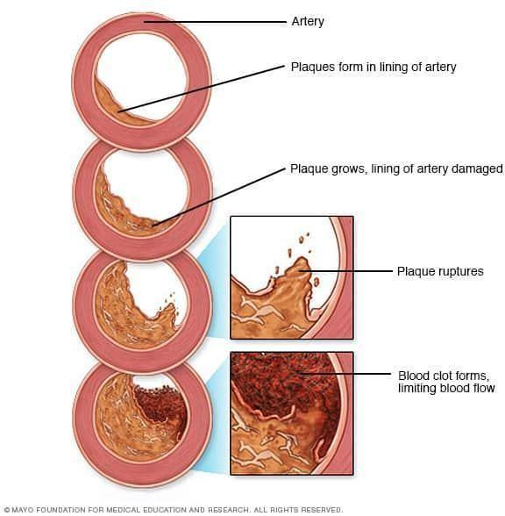

Besides high cholesterol, damage to the coronary arteries may be caused by:
Diabetes or insulin resistance, High blood pressure, Not getting enough exercise (sedentary lifestyle), Smoking or tobacco use.

DESIGN OF STENTS:

A stent is a tiny tube that can play a big role in treating your heart disease. It helps keep your arteries -- the blood vessels that carry blood from your heart to other parts of your body, including the heart muscle itself -- open.
Most stents are made out of wire mesh and are permanent. Some are made out of fabric. These are called stent grafts and are often used for larger arteries.
Others are made of a material that dissolves and that your body absorbs over time. They're coated in medicine that slowly releases into your artery to prevent it from being blocked again.

Why Would You Need a Stent?

If a fatty substance called plaque builds up inside an artery, it can reduce blood flow to your heart. This is called coronary heart disease and it can cause chest pain.
The plaque can also cause a blood clot that blocks blood flowing to your heart, which may lead to a heart attack.
By keeping an artery open, stents lower your risk of chest pain. They can also treat a heart attack that's in progress.

Doctor usually inserts a stent using a minimally invasive procedure. They will make a small incision and use a catheter to guide specialized tools through your blood vessels to reach the area that needs a stent. This incision is usually in the groin or arm. One of those tools may have a camera on the end to help your doctor guide the stent. During the procedure, doctor may also use an imaging technique called an angiogram to help guide the stent through the vessel.
Using the necessary tools, doctor will locate the broken or blocked vessel and install the stent. Then they will remove the instruments from your body and close the incision.

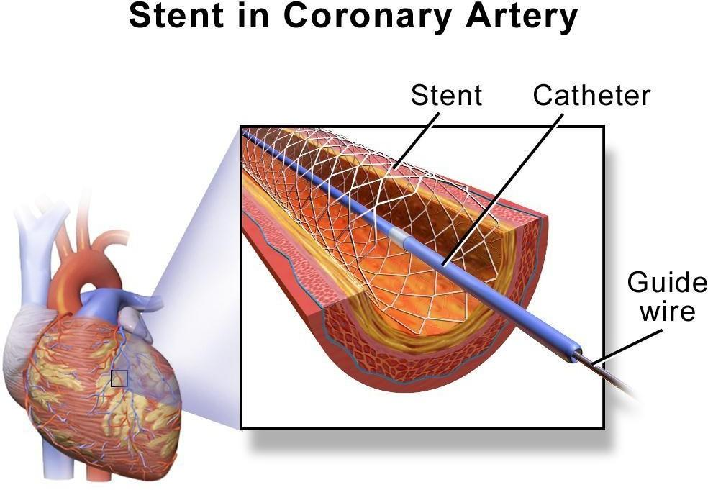

DESIGN:

Most of these stents are constructed from a nickel titanium alloy. Balloon expandable stents are susceptible to permanent deformation when they are compressed extrinsically, which is not an issue in the coronary tree. Self-expanding stents do not have this limitation. Furthermore, self- expanding stents have less axial stiffness and are thus more flexible and will conform to the shape of the vessel rather than the vessel conforming to the shape of the stent. Balloon expandable stents, by virtue of their design, resist expansion by the balloon, but they have less acute recoil when they are placed in a poorly compliant lesion. However, after the initial deployment, the stent is at its maximal diameter and cannot get larger, whereas a self-expanding stent that is appropriately oversized for the vessel will exhibit a chronic outward force on the lesion and may lead to a larger lumen over time. For the reasons above, there are some coronary lesions where balloon expandable stents are not ideal, such as aneurysmal, ectatic vessels, thrombus laden vessels, and vessels that are tapering with a large size mismatch between distal reference and proximal reference vessels.

PACE MAKERS:

A pacemaker is a small device that's placed (implanted) in the chest to help control the heartbeat. It's used to prevent the heart from beating too slowly. Implanting a pacemaker in the chest requires a surgical procedure.

A pacemaker is also called a cardiac pacing device.

Types:
Single chamber pacemaker. This type usually carries electrical impulses to the right ventricle of your heart.
Dual chamber pacemaker. This type carries electrical impulses to the right ventricle and the right atrium of your heart to help control the timing of contractions between the two chambers.
Biventricular pacemaker. Biventricular pacing, also called cardiac resynchronization therapy, is for people who have heart failure and heartbeat problems. This type of pacemaker stimulates both of the lower heart chambers (the right and left ventricles) to make the heart beat more efficiently. A pacemaker is implanted to help control your heartbeat. Your doctor may recommend a temporary pacemaker when you have a slow heartbeat (bradycardia) after a heart attack, surgery or medication overdose but your heartbeat is otherwise expected to recover. A pacemaker may be implanted permanently to correct a chronic slow or irregular heartbeat or to help treat heart failure. Pacemakers work only when needed. If your heartbeat is too slow (bradycardia), the pacemaker sends electrical signals to your heart to correct the beat.

Some newer pacemakers also have sensors that detect body motion or breathing rate and signal the devices to increase heart rate during exercise, as needed.

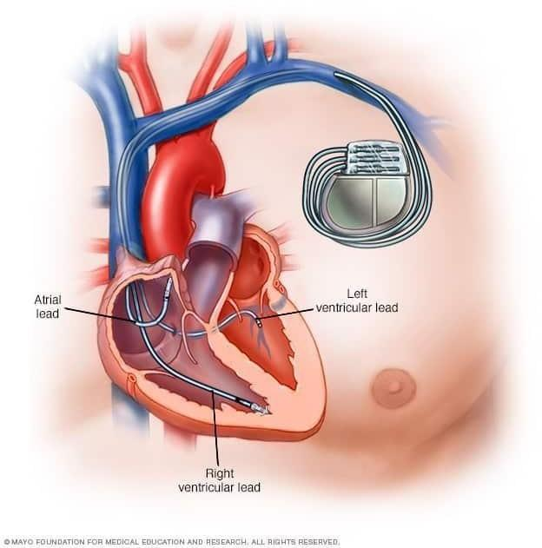
COURTESY: WIKIMEDIA COMMONS
A pacemaker has two parts:
- Pulse generator. This small metal container houses a battery and the electrical circuitry that controls the rate of electrical pulses sent to the heart.
- Leads (electrodes). One to three flexible, insulated wires are each placed in one or more chambers of the heart and deliver the electrical pulses to adjust the heart rate. However, some newer pacemakers don't require leads. These devices, called leadless pacemakers, are implanted directly into the heart muscle.

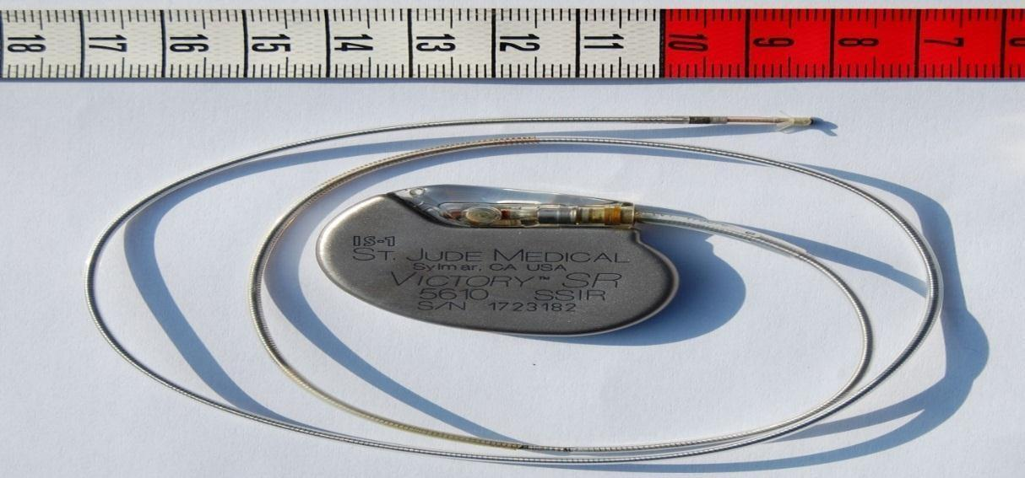

DEFIBRILLATORS:

Defibrillators are devices that send an electric pulse or shock to the heart to restore a normal heartbeat. They are used to prevent or correct an arrhythmia, an uneven heartbeat that is too slow or too fast. If the heart suddenly stops, defibrillators can also help it beat again. Different types of defibrillators work in different ways. Automated external defibrillators (AEDs), which are now found in many public spaces, are used to save the lives of people experiencing cardiac arrest. Even untrained bystanders can use these devices in an emergency.
Other defibrillators can prevent sudden death among people who have a high risk of a life- threatening arrhythmia. They include implantable cardioverter defibrillators (ICDs), which are surgically placed inside your body, and wearable cardioverter defibrillators (WCDs), which rest on the body. It can take time and effort to get used to living with a defibrillator, and it is important to be aware of possible complications.
There are three types of defibrillators: AEDs, ICDs, and WCDs.

An AED is a lightweight, battery-operated, portable device that checks the heart’s rhythm and sends a shock to the heart to restore normal rhythm. The device is used to help people having cardiac arrest.
Sticky pads with sensors, called electrodes, are attached to the chest of someone who is having cardiac arrest. The electrodes send information about the person's heart rhythm to a computer in the AED. The computer analyzes the heart rhythm to find out whether an electric shock is needed. If it is needed, the electrodes deliver the shock.

ICDs are placed through surgery in the chest or stomach area, where the device can check for arrhythmias. Arrhythmias can interrupt the flow of blood from your heart to the rest of your body or cause your heart to stop. The ICD sends a shock to restore a normal heart rhythm.
An ICD can give off a low-energy shock that speeds up or slows down an abnormal heart rate, or a high-energy shock to correct a fast or irregular heartbeat. If low-energy shocks do not restore your normal heart rhythm, the device may switch to high-energy shocks for defibrillation.
ICDs are similar to pacemakers, but pacemakers deliver only low-energy electrical shocks. ICDs have a generator connected to wires that detect your heart’s beats and deliver a shock when needed. Some ICDs have wires that rest inside one or two chambers of the heart. Others do not have wires going into the heart chambers but instead rest on the heart to monitor its rhythm.
The ICD can also record the heart's electrical activity and heart rhythms. The recordings can help your healthcare provider fine-tune the programming of the device so it works better to correct irregular heartbeats. The device is programmed to respond to the type of arrhythmia you are most likely to have.

WCDs have sensors that attach to the skin. They are connected by wires to a unit that checks your heart’s rhythm and delivers shocks when needed. Like an ICD, the WCD can deliver low- and high-energy shocks. The device has a belt attached to a vest that is worn under your clothes. Your provider fits the device to your size. It is programmed to detect a specific heart rhythm.

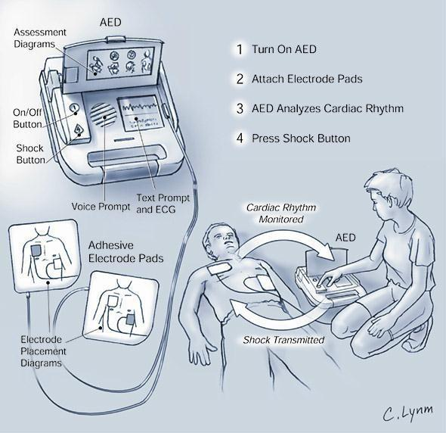
HUMAN ORGAN SYSTEMS AND BIO ORGANS – I:

LUNGS AS A PURIFICATION SYSTEM:

Introduction:
Every cell in your body needs oxygen to live. The air we breathe contains oxygen and other gases. The respiratory system's main job is to move fresh air into your body while removing waste gases. Once in the lungs, oxygen is moved into the bloodstream and carried through your body. At each cell in your body, oxygen is exchanged for a waste gas called carbon dioxide. Your bloodstream then carries this waste gas back to the lungs where it is removed from the bloodstream and then exhaled. Your lungs and the respiratory system automatically perform this vital process, called gas exchange.
In addition to gas exchange, your respiratory system performs other roles important to breathing. These include:

- Bringing air to the proper body temperature and moisturizing it to the right humidity level.
- Protecting your body from harmful substances. This is done by coughing, sneezing, filtering, or swallowing them.
- Supporting your sense of smell.

Lungs help in the purification of blood. Arteries carry pure oxygenated blood from the heart to other parts of the body. Veins carry impure venous blood back from other parts of the body to the right side of the heart. This impure blood goes to the lungs for purification.
When the breath is inhaled, oxygen from the air comes in contact with the impure blood and the blood takes up oxygen. The waste matter in the blood releases carbonic acid and the blood is purified. The purified blood is carried to the heart by the veins.

Architecture:
The lung parenchyma is mainly comprised of numerous air-containing passages and intervening fine structures, corresponding to alveolar ductal lumens and alveoli, as well as alveolar septa and small pulmonary vessels occupying 10% of total parenchymal volume.
The primary function of the lungs is gas exchange. However, the lungs perform several important

non-respiratory functions that are vital for normal physiology.
The lung, with its unique ability to distend and recruit pulmonary vasculature, acts as a reservoir of blood, fine-tuning preload to the left heart to optimize cardiac output.

- The lung acts as a filter against endogenous and exogenous emboli, preventing them from accessing systemic circulation.
- Pulmonary epithelium forms the first line of defense against inhaled particles.
- Pulmonary endothelial cells are responsible for the uptake, metabolism, and biotransformation of several exogenous and endogenous substances.
- Pulmonary metabolic capacity is easily saturated, but pulmonary endothelial binding of some drugs alters their pharmacokinetics.
∙
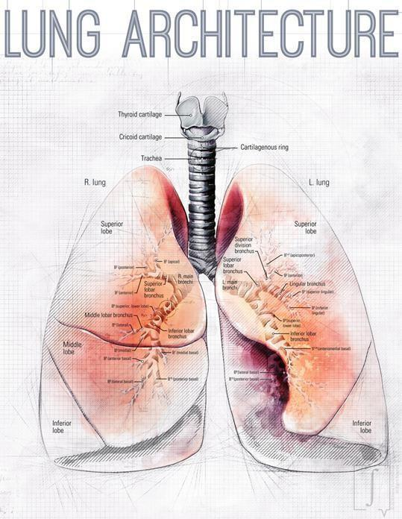
COURTESY: EDWARD RUDOLF WEIBEL

GAS EXCHANGE MECHANISMS:

Air enters the body through the mouth or nose and quickly moves to the pharynx or throat. From there, it passes through the larynx, or voice box, and enters the trachea.
The trachea is a strong tube that contains rings of cartilage that prevent it from collapsing. Within the lungs, the trachea branches into a left and right bronchus. These further divide into smaller and

smaller branches called bronchioles. The smallest bronchioles end in tiny air sacs. These are called alveoli.
They inflate when a person inhales and deflate when a person exhales. During gas exchange oxygen moves from the lungs to the bloodstream. At the same time, carbon dioxide passes from the blood to the lungs. This happens in the lungs between the alveoli and a network of tiny blood vessels called capillaries, which are located in the walls of the alveoli.
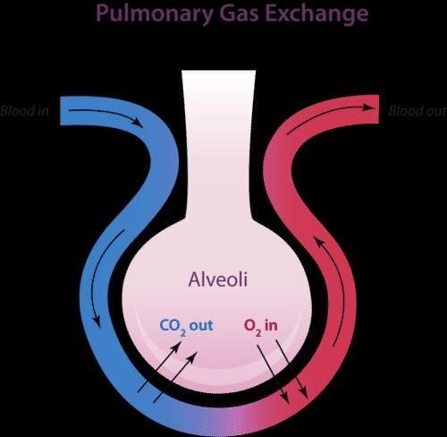
ILLUSTRATED BY D.M. GOMEZ

The walls of the alveoli share a membrane with the capillaries. That's how close they are. This lets oxygen and carbon dioxide diffuse, or move freely, between the respiratory system and the bloodstream.
Oxygen molecules attach to red blood cells, which travel back to the heart. At the same time, the carbon dioxide molecules in the alveoli are blown out of the body the next time a person exhales. The gas exchange allows the body to replenish the oxygen and eliminate carbon dioxide. Doing both is necessary for survival.

SPIROMETRY:

Spirometry (spy-ROM-uh-tree) is a common office test used to assess how well your lungs work by measuring how much air you inhale, how much you exhale, and how quickly you exhale. Spirometry is used to diagnose asthma, chronic obstructive pulmonary disease (COPD), and other conditions that affect breathing.
175 years have elapsed since John Hutchinson introduced the world to his version of an apparatus that had been in development for nearly two centuries, the spirometer.

Spirometers can be divided into two basic groups:
- Volume-measurement devices (e.g. wet and dry spirometers).
- Flow-measurement devices (e.g. pneumotachograph systems, mass flow meters).
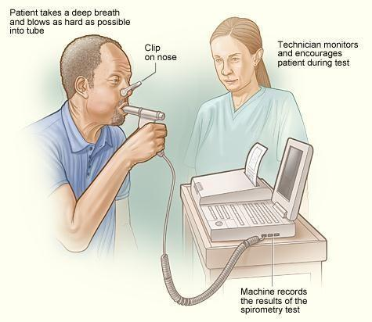

Requirements of an acceptable spirometer are:
- Spirometers must be able to accumulate volume for ≥15 s.
- The measuring volume should be ≥8 L (body temperature and pressure, saturated).
- The accuracy of reading should be at least ±3% (or ±0.05 L) with flows from 0–14 L per s.
- The total resistance to airflow at 14 L per s should be <1.5 cmH2O per L per s (<0.15 kPa per L per s).

HOW TO CALCULATE THE NORMAL RATE OF RESPIRATION IN A SPIROMETER:

The FEV1/FVC Ratio (FEV1%) parameter is calculated by dividing the measured FEV1 value by the measured FVC value. The Measured column shows the absolute (numerical) ratio, and the Predicted column shows the ratio expressed as a percentage. In healthy adults of the same gender, height, and age, the normal Predicted percentage should be between 70% and 85%.

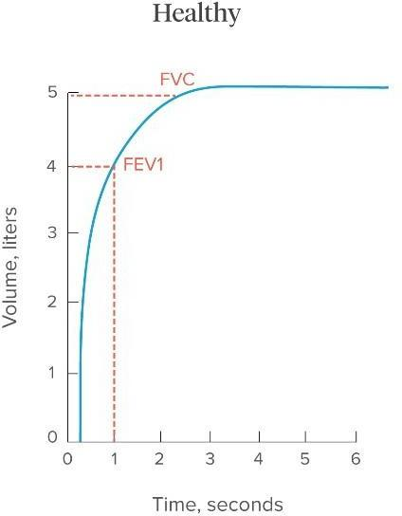

ABNORMAL LUNG PHYSIOLOGY:

Percentages lower than 70% are considered abnormal. This is an important measurement because obstructive diseases such as COPD, chronic bronchitis, and emphysema cause increased airway resistance to expiratory airflow, and may result in percentages of 45% to 60%. Restrictive diseases such as pulmonary fibrosis tend to reduce both FEV1 and FVC values, so the percentage can remain within the normal range, or even increase.

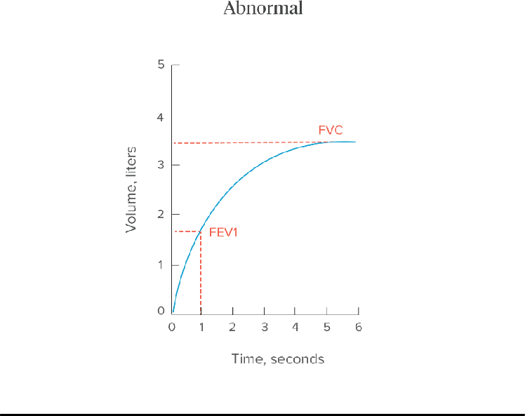

COPD:

Chronic obstructive pulmonary disease (COPD) is a chronic inflammatory lung disease that causes obstructed airflow from the lungs. Symptoms include breathing difficulty, cough, mucus (sputum) production, and wheezing. It's typically caused by long-term exposure to irritating gases or particulate matter, most often from cigarette smoke. People with COPD are at increased risk of developing heart disease, lung cancer, and a variety of other conditions.
Emphysema and chronic bronchitis are the two most common conditions that contribute to COPD. These two conditions usually occur together and can vary in severity among individuals with COPD.

Symptoms:
COPD symptoms often don't appear until significant lung damage has occurred, and they usually worsen over time, particularly if smoking exposure continues.

Signs and symptoms of COPD may include:
  - Shortness of breath, especially during physical activities
  - Wheezing
  - Chest tightness
  - A chronic cough that may produce mucus (sputum) that may be clear, white, yellow, or greenish
  - Frequent respiratory infections
  - Lack of energy
  - Unintended weight loss (in later stages)
  - Swelling in ankles, feet, or legs

Tests may include:
  - Lung (pulmonary) function tests.
  - Chest X-ray.
  - CT scan.
  - Arterial blood gas analysis.
  - Laboratory tests.

Medications:
Several kinds of medications are used to treat the symptoms and complications of COPD. You may take some medications regularly and others as needed.
  - Bronchodilators
  - Inhaled steroids
  - Combination inhalers
  - Oral steroids
  - Phosphodiesterase-4 inhibitors
  - Theophylline
  - Antibiotics

Mechanical ventilation is a lifesaving therapy in patients who have acute respiratory failure due to

chronic obstructive pulmonary disease (COPD). Mechanical ventilation either invasive or non- invasive has an important role in the management of acute exacerbation of COPD (AECOPD).

VENTILATOR:

Mechanical ventilators are machines that act as bellows to move air in and out of your lungs. Your respiratory therapist and doctor set the ventilator to control how often it pushes air into your lungs and how much air you get. You may be fitted with a mask to get air from the ventilator into your lungs or you may need a breathing tube if your breathing problem is more serious. When you’re ready to be taken off the ventilator, your healthcare team will “wean” you or decrease the ventilator support until you can start breathing on your own.
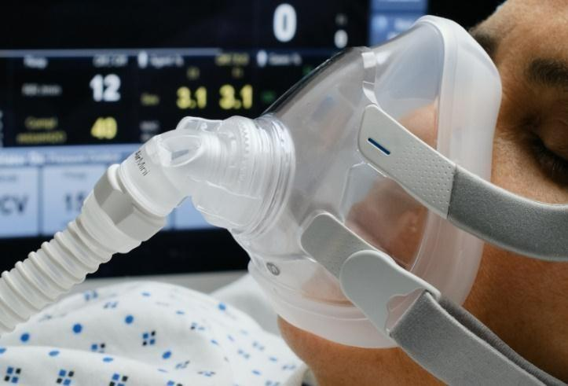

HEART LUNG MACHINE:

A heart-lung machine is an apparatus that does the work both of the heart (i.e., pumps blood) and the lungs (i.e., oxygenates the blood) during, for example, open-heart surgery The basic function of the machine is to oxygenate the body's venous supply of blood and then to pump it back into the arterial system.
Blood returning to the heart is diverted through the machine before returning to the arterial circulation. Some of the more important components of these machines include pumps, oxygenators, temperature regulators, and filters. The heart-lung machine also provides intracardiac suction, filtration, and temperature control.

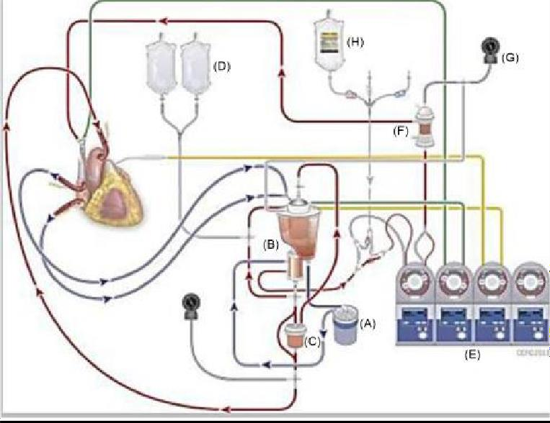

Blood drains by gravity or with the use of gentle suction into the oxygenator venous reservoir labeled (B). (A) represents the arterial pump that pumps the blood from the venous reservoir (B) and delivers blood to the membrane oxygenator which is attached to the lower part of the venous reservoir. Once oxygen, carbon dioxide, and heat exchange have occurred the blood is directed thru an arterial blood filter (C). A purge line to the uppermost part of the filter serves for the removal of any microemboli that may have been introduced into the blood during its passage through the circuit. The oxygenated blood is introduced back into the patient’s circulatory system through cannulae (a large tube connected to the circuit) placed in the ascending aorta. The line attached to intravenous bags labeled (D) provides a method for priming the CPB circuit with electrolyte fluid or a port for adding blood during bypass. Four roller pumps labeled (E) in the diagram are auxiliary. The one on the far left is used to pump a cardioplegia solution with a mixture of blood and additives, labeled (H), and used to arrest the heart. This solution is cooled with a separate heat exchanger labeled (F).

KIDNEY AS FILTRATION SYSTEM:

Introduction:
Kidneys remove wastes and extra fluid from the body. Kidneys also remove acid that is produced by the cells of the body and maintain a healthy balance of water, salts, and minerals—such as sodium, calcium, phosphorus, and potassium—in the blood. Without this balance, nerves, muscles, and other tissues in the body may not work normally.
Kidneys also make hormones that help
  - Control blood pressure.
  - Make red blood cells NIH external link.
- Keeps bones strong and healthy.
Architecture:
The kidneys are two bean-shaped organs, each about the size of a fist. They are located just below
the rib cage, one on each side of the spine. Healthy kidneys filter about a half cup of blood every minute, removing wastes and extra water to make urine. The urine flows from the kidneys to the bladder through two thin tubes of muscle called ureters, one on each side of the bladder. Your bladder stores urine. Kidneys, ureters, and bladder are part of your urinary tract.

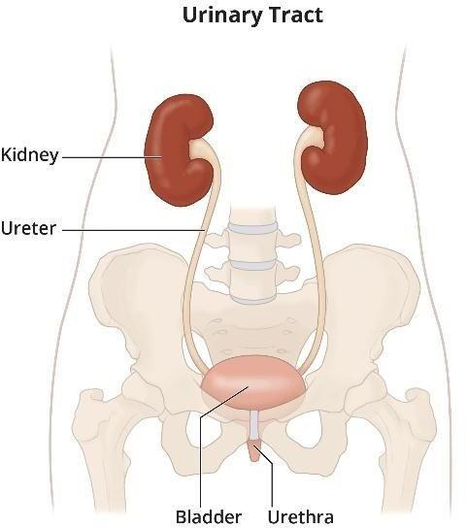
COURTESY: HANS BACHOFEN

MECHANISM OF FILTRATION:

Each kidney is made up of about a million filtering units called nephrons. Each nephron includes a filter, called the glomerulus, and a tubule. The nephrons work through a two-step process: the glomerulus filters blood, and the tubule returns needed substances to your blood and removes wastes.
Each nephron has a glomerulus to filter your blood and a tubule that returns needed substances to your blood and pulls out additional wastes. Wastes and extra water become urine.
The glomerulus filters your blood. As blood flows into each nephron, it enters a cluster of tiny blood vessels—the glomerulus. The thin walls of the glomerulus allow smaller molecules, wastes, and fluid—mostly water—to pass into the tubule. Larger molecules, such as proteins and blood cells, stay in the blood vessel. The tubule returns needed substances to your blood and removes wastes.

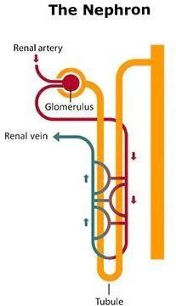
COURTESY: SAMUEAL SCHRUCHB

A blood vessel runs alongside the tubule. As the filtered fluid moves along the tubule, the blood vessel reabsorbs almost all of the water, along with minerals and nutrients your body needs. The tubule helps remove excess acid from the blood. The remaining fluid and wastes in the tubule become urine.

How does blood flow through my kidneys?
Blood flows into the kidney through the renal artery. This large blood vessel branches into smaller and smaller blood vessels until the blood reaches the nephrons. In the nephron, blood is filtered by the tiny blood vessels of the glomeruli and then flows out of the kidney through the renal vein.
Blood circulates through your kidneys many times a day. In a single day, kidneys filter about 150 quarts of blood. Most of the water and other substances that filter through your glomeruli are returned to the blood by the tubules. Only 1 to 2 quarts become urine.
When the kidney doesn't function properly, chronic kidney disease occurs when a disease or condition impairs kidney function, causing kidney damage to worsen over several months or years.

CKD:

Chronic kidney disease includes conditions that damage your kidneys and decrease their ability to keep you healthy by filtering wastes from your blood. If kidney disease worsens, wastes can build to high levels in your blood and make you feel sick. You may develop complications like
  - high blood pressure
  - anemia (low blood count)
  - weak bones

  - poor nutritional health
  - nerve damage

Symptoms:
People with CKD may not feel ill or notice any symptoms. The only way to find out for sure if you have CKD is through specific blood and urine tests. These tests include the measurement of both the creatinine level in the blood and the protein in the urine.

Treatment:
Depending on the cause, some types of kidney disease can be treated. Often, though, chronic kidney disease has no cure. Treatment usually consists of measures to help control signs and symptoms, reduce complications, and slow the progression of the disease. If your kidneys become severely damaged, you might need treatment for end-stage kidney disease.

DIALYSIS:

Dialysis is a procedure to remove waste products and excess fluid from the blood when the kidneys stop working properly. It often involves diverting blood to a machine to be cleaned.
There are 2 main types of dialysis:
  - Haemodialysis involves diverting blood into an external machine, where it's filtered before being returned to the body
  - Peritoneal dialysis involves pumping dialysis fluid into the space inside your abdomen (tummy) to draw out waste products from the blood passing through vessels lining the inside of the abdomen

